Drat’s SMC Trading System

## Indicators setup

* TRAMA [LuxAlgo] 20 close (black) ([source](https://www.tradingview.com/v/p8wGCPi6/))
* TRAMA [LuxAlgo] 50 close (purple) (Use TRAMA again and change parameter to 50)
* TRAMA [LuxAlgo] 200 close (red) (same but 200)
  + **Alternative:** Multiple TRAMA (3-in-1 indicator) ([source](https://www.tradingview.com/script/gsHzmBET-Multiple-Trend-Regularity-Adaptive-Moving-Average/))
* ICT Concepts [LuxAlgo] ([source](https://www.tradingview.com/v/ib4uqBJx/))
  + Show FVGs
* Smart Money Concepts [LuxAlgo] ([source](https://www.tradingview.com/v/CnB3fSph/))
  + Show Fair Value Gaps
  + Show Premium/Discount Zones

**Recommended Timeframe**: 5 minutes, 45 minutes

## Candle Styles

Use Standard candles to identify candle patterns (cup & handle, flags, etc.), and price targets, boxes, etc.

Use Heikin Ashi candles to actively monitor the entry parameters. Identify doji candles and entries/exits. Doji indicate a possible reversal, especially after a strong waterfall (series of red candles).

## System Parameters

### Entry Parameters

Identify a red waterfall followed by a reversal.

The reversal should break through 20 MA and failed breakout. Enter on the **second breakout of 20 MA**.

Thoughts: If red waterfall followed by a reversal, could it be a green rocket followed by a reversal as well?

#### Quick Reversals Wins

when 20ma just flipped above the candles and then you have 50ma above at like 30 points from PA, you send a 2-5unit orders with TP at 50ma and you walk away from the screen.

‎

Come back 30 min later and you won! (Drat)

### Exit Parameters

Hold position until price action breaks below 20 TRAMA again.

*Potential Alternative exit*: If PA is close to a major resistance and a doji appears on HA candles, it *might* be a good exit point (needs testing).

## Examples

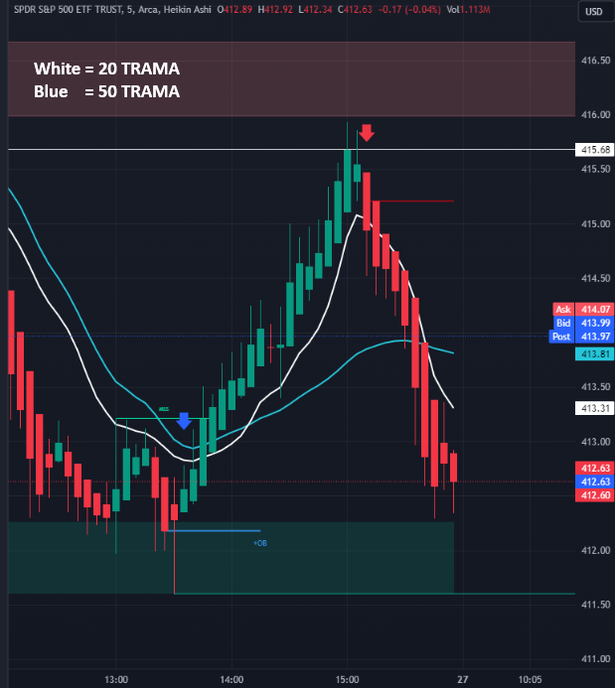

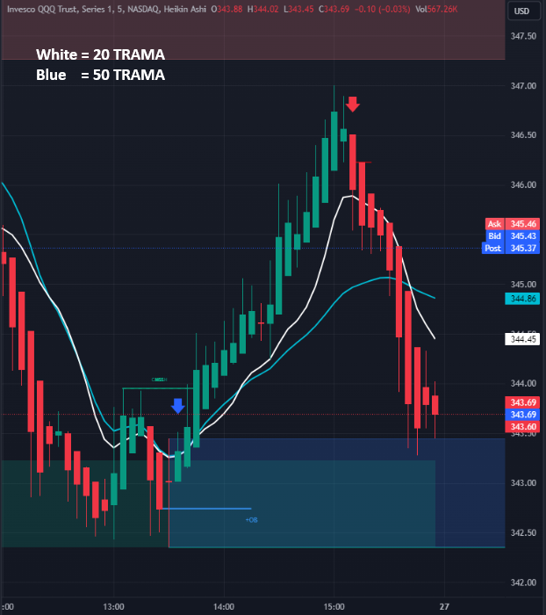

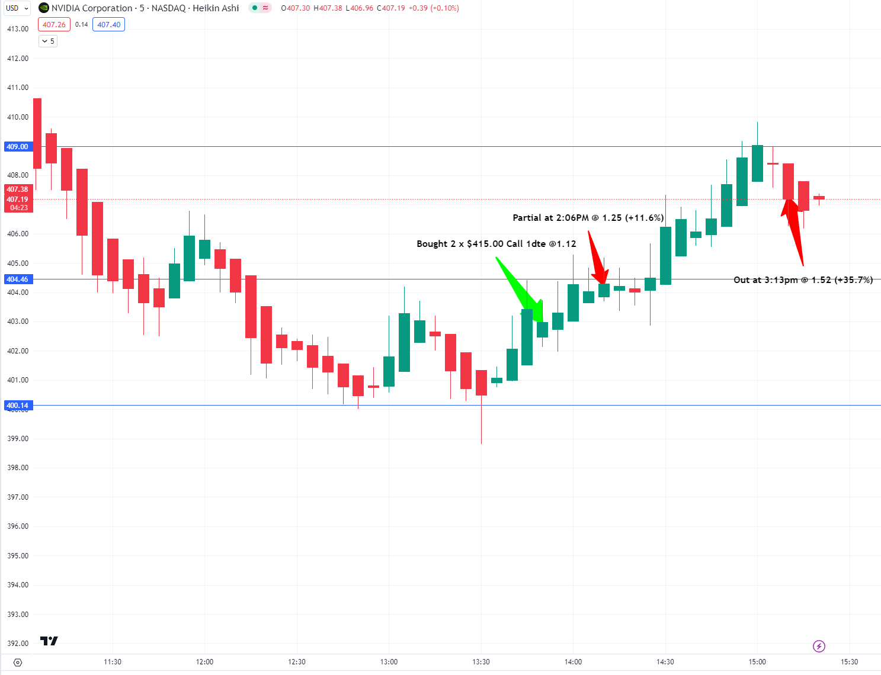

## Candle Patterns

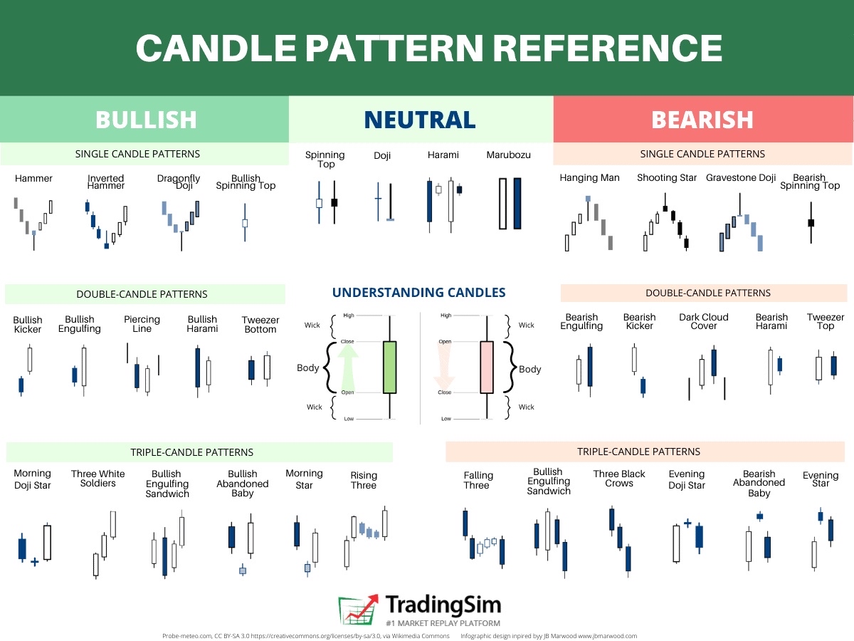

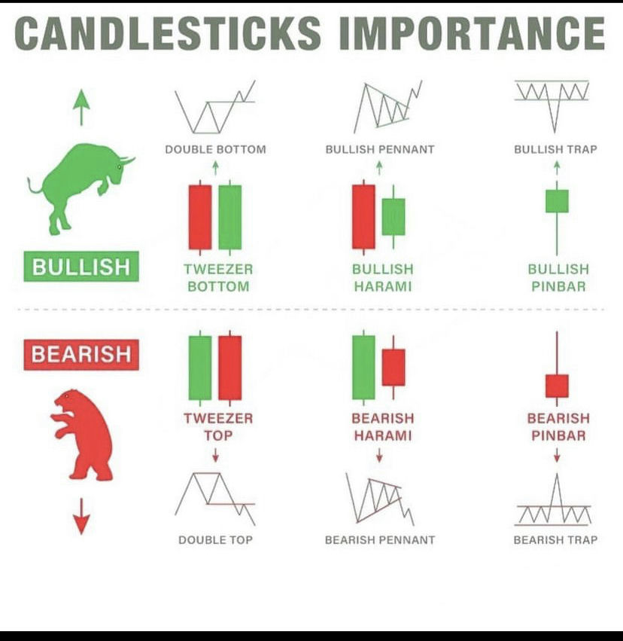

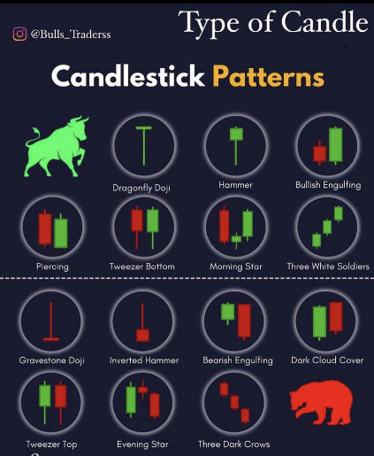

## Bibliography

Works Cited

Drat, Jimmy. “Drat's Reversal Strategy.” *The Real World*, 2023, <https://app.jointherealworld.com/chat/01GGDHHZ377R1S4G4R6E29247S/01GSA8H3F96FDNC7RF6H9F02KF/01HDHYDG93TSQ31YQ89ADAPX4X>. Accessed 26 10 2023.

Drat, Jimmy. “Strategy Indicators.” *The Real World*, 2023, <https://app.jointherealworld.com/chat/01GGDHHZ377R1S4G4R6E29247S/01GSA8H3F96FDNC7RF6H9F02KF/01HDHXYQY6BXR4F6VA73Y4K2GQ>. Accessed 26 10 2023.